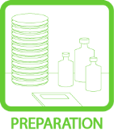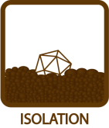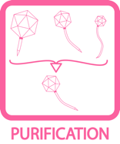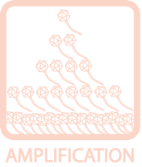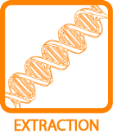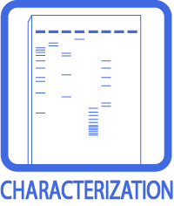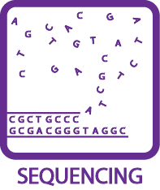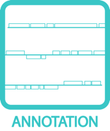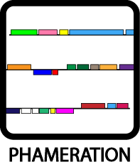
Restriction Enzyme Digest
OBJECTIVE
Create a “Phage Phingerprint” to compare a phage’s DNA to that of other phages/clusters by digesting it with several restriction enzymes, and then running those digests on an agarose gel.
BACKGROUND
Restriction enzymes are enzymes that cut DNA at specific sites. Each restriction enzyme recognizes a particular DNA sequence (often 4 or 6 bps long, called restriction sites) and cleaves both strands of the DNA at that location. Phage genomes differ in the numbers and/or locations of these restriction sites, so will give different numbers and/or lengths of DNA fragments when digested. If several different enzymes are used to digest genomic DNA—and each is run on an agarose gel—a phage‐specific “Phingerprint” will emerge and can be used for comparison.
APPROXIMATE TIME NEEDED
Setting up the restriction digests: 15 – 30 minutes.
Waiting for the DNA to digest: 60 minutes.
Loading the agarose gel: 10 – 20 minutes.
Running the agarose gel: 45 – 90 minutes.
Taking a picture of the gel: 10 minutes.
MATERIALS NEEDED
Equipment
- Micropipettor
- 37°C incubator/water bath
- Standard agarose gel supplies (gel box, buffers, comb, casting tray, etc.)

Consumables/Reagents (See online media preparation guides)
- Microcentrifuge (“Eppendorf”) tubes
- Restriction enzymes (BamHI, ClaI, EcoRI, HaeIII, HindIII) w/buffers. [Can order via NEB]
- 10X BSA
- ddH2O
- Agarose
- TAE or TBE running buffer for agarose gels
- Appropriate micropipette tips
HELPFUL TIPS
- Standard Pitt enzymes are: BamHI, ClaI, EcoRI, HaeIII, HindIII.

- Enzymes are stored at –20°C. They MUST stay cold. Minimize the amount of time they spend out of the freezer.

- DNA concentration must be determined before beginning. Use a Nanodrop or spec.

- Highly concentrated phage genomic DNA tends to aggregate in solution. Heating for 15 minutes at 55°C before pipetting can help ensure consistent concentration.

- Do not vortex genomic DNA, as this can cause it to shear.

- While the volumes being handled are small, refrain from using PCR tubes since they tend to disappear from water baths.

- Ethidium bromide is a known carcinogen, handle with care.

PROCEDURES

- Final reaction volume for each digestion is 15 μL.

- To each of 5 clearly labeled new microcentrifuge tubes, add:
$x$ μL DNA (≅250ng; 150 – 350 ng is fine, use concentration of DNA sample to calculate)
1.5 μL 10X buffer appropriate for the enzyme (see catalog, or match colors for NEB enzymes)
1.5 μL 10X BSA
$y$ μL ddH2O ($x+y$ = 11.5 μL)
0.5 μL of enzyme (use BamHI, ClaI, EcoR, HaeIII, and HindIII, generally from NEB)

NOTE THE CONCENTRATION of reagents, since stock BSA concentration is 100X.
Always add the reagent/sample in order of decreasing volumes.

- Mix gently by pipetting the sample up and down, followed by a quick spin.

- Incubate at 37°C for 60 minutes. Do not go over one hour, as this may cause star activity (where the enzyme digests at sites similar to—but not identical to—its restriction site).

- Load the samples and run on a 0.7% agarose gel alongside a DNA ladder.

- For a small gel, weigh and transfer 0.35 g of agarose to an Erlenmeyer flask.

- Add 50 mL of 1X TBE, loosely plug the Erlenmeyer flask with lab wipes, and microwave the mixture for 1 minute.

- Let the solution cool until it is warm to the touch, then pour into a small casting tray.

- Add 2 μL of ethidium bromide, mixture gently with the pipet tip, dispose of the tip in the designated waste container.

- Insert an appropriate comb, wait for the solution to solidify (generally ~10 mintues).

- Add 2 μL of Ficoll dye to each digest, then load full sample into the appropriate well in the gel. Alternatively, the samples may be frozen until a gel is prepared.

- Run the gel at 100V for 30 – 40 minutes.

- Once the gel has run, take a picture of the fragment distribution.

- Compare picture to virtual/real digests of other phages/clusters to determine whether the phage is new or a previously characterized phage AND what cluster it might belong to.

