Phagehunting Program
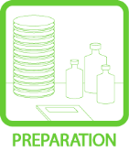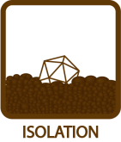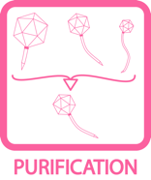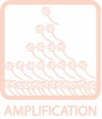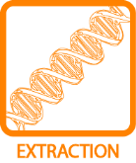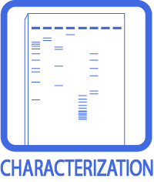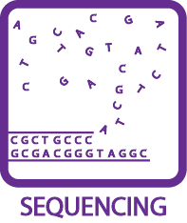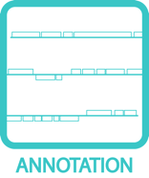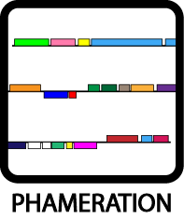
Small-Scale Phage Concentration
OBJECTIVE
To concentrate a phage sample using a small-scale prep.
BACKGROUND
There are a number of ways to concentrate a phage sample in preparation for DNA extraction. This one requires about 15 mL of sample.
APPROXIMATE TIME NEEDED
Preparing Ammonium Sulfate Solution: 2 hours
Initial phage pelleting: 3 hours (including a 2 hour incubation)
1st Dialysis: Overnight
2nd Dialysis: 2 hours
MATERIALS NEEDED
Equipment
- Centrifuges, high-speed and micro-
- Stir plates and stir bars
- 1 L Beakers

Consumables/Reagents
- Saturated ammonium sulfate solution
- Dialysis tubing (MWCO 15000), ~4”
- 50 mL conical tubes
- 2000 mL phage buffer (4 big bottles, all without CaCl₂)
- 1.5 mL microcentrifuge tubes
- ~1000 mL dH₂O
HELPFUL TIPS
- Instead of preparing a fresh lysate, alternatively, if a sufficient volume of lysate is available, simply use 15 mL of lysate with titer greater than 1 × 10¹⁰.

- 3500 g is approximately 7000 with the SA-600 rotor. However, if using the large centrifuge in the Hatfull Laboratory, spin at 5000 rpm.

- Dialysis tubing must always be kept moist. They should be handled with gloves.

PROCEDURES

- Prepare a filtered lysate from 2 – 4 small plates of “webbed” mycobacteriophage plates and filter (See TOOLBOX: Titering).

- Prepare saturated ammonium sulfate.

- Dissolve 80 g ammonium sulfate salt in 100 mL in dH₂O, stir for at least 2 hours on stir plate.

- Allow the un-dissolved crystals to settle (~1 minute).

- Remove solution, leaving behind un-dissolved crystals, and place in 50 mL conical tubes. This should be prepared fresh each time.

- Add an equal volume of saturated ammonium sulfate to lysate, invert tube to mix gently, and incubate on ice 2 hours.

- Pellet at 3500 x g for 10 min. at 4°C in a 50 mL conical tube (5000 rpm using the Hatfull Laboratory large fixed-angle high-speed centrifuge).

- Mark the tube where the pellet is expected.

- Pellet this twice but do not remove the supernatant after the first spin! The first time, the phage particles are in “chunks” of glassy pellet that are observable by inverting the tube gently. The second time, the pellet is more visible.

- During the above centrifugations, soak ~4” of MWCO 15,000 dialysis tubing in 750 mL diH₂O for approximately 10 minutes.

- Immediately remove the supernatant the second it is removed from the centrifuge. If no pellet is seen, try centrifuging for 30 min. The pellet may be difficult to identify, but it would appear as a small glob.

- Re-suspend phage in 500 μL Phage buffer.

- Dialyze the 500 μL phage sample at 4°C with stirring overnight.

- Fill a 1 L beaker with phage buffer (2 big bottles) without CaCl₂. Insert a magnetic stir bar. Chill the beaker with buffer in the cold room for ~60 minutes.

- Clip one end of dialysis tubing and fill tubing with phage sample. Clip the other end of the tubing, leaving about ¼ inch room to spare. Place the sample in the beaker.

- Slowly turn up the dial of the stir plate, allow the tube to spin slowly (minimal movement is just fine). Vigorous stirring may cause the tube to be trapped by the stir bar.

- Allow the sample to be slowly spinning and continuously floating. Leave at 4°C overnight.

- Remove the phage buffer and fill the beaker with fresh phage buffer, dialyze the sample for an additional 2 hours.

- Transfer sample to two 1.5 mL microcentrifuge tubes. This concentrated sample can be used for DNA Extraction (See EXTRACTION: PCI DNA Extraction).

Protocol originally from Dr. Gregory Broussard
Modified for Phagehunting Program

