|  |  |  |
| --- | --- | --- |
|  | | |
| Macintosh HD:Users:Enoch:Desktop:New Protocols:Logos and Graphics:Workflow:ToolboxRound.png | | **Titering** |
| **OBJECTIVE** | | |
|  | To quantify the number of phage in a sample expressed as PFU (plaque forming unit)/mL. | |
| **BACKGROUND** | | |
|  | There are two ways to do a titer. The full plate titer allows for easier and more accurate plaque counting, but also requires more plates and time than the “quick and dirty” method. Either method can lead to successful results. The best titer calculation is always obtained from a single plate with 20 – 200 plaques. | |
| **APPROXIMATE TIME NEEDED** | | |
|  | Serial Dilution: **30 minutes**  Plating: **30 minutes** | |
| **MATERIALS NEEDED** | | |
|  | Equipment   * 37°C incubator * Pipettors, micro- and serological   Consumables/Reagents (See online media preparation guides)   * Agar plates * *Mycobacterium smegmatis* plating stock *(0.5 mL/plate)* * Top agar/MBTA plating mixture *(4.5 mL/plate)* * Phage pick, lysate, or plaque * Appropriate micropipette tips * Serological pipettes | |
| **HELPFUL TIPS** | | |
|  | * Phage titer is expressed in PFU (Plaque Forming Units)/mL. Lysates with a final concentration greater than 109 PFU/ml are “High Titer” lysates. Current data suggest that the higher the titer, the more stable the lysate. * Full plate titers have higher degree of accuracy. However, the “Quick and Dirty” titer has a sufficient accuracy for most needs in phage biology. Consider carefully what the need is before determining which method to use. * When learning how to do a titer, it is recommended to make two dilutions sets, and perform both the full plate and the “Quick and Dirty” methods in tandem. * While the best countable plate has between 20 – 200 plaques, dilution techniques must be verified by observing a 10-fold decrease in plaque numbers across the dilutions. * Top agar/MBTA plating mixture is prepared by mixing 7H9 (w/ CaCl2 and other host-specific additives) and stock MBTA in a 1:1 ratio. | |

**PROCEDURES**

**Full Plate Titer**

1. Serially dilute lysate to 10–1, 10–2, 10–3, 10–4, 10–5, 10–6, 10–7, 10–8, 10–9, and 10–10 in phage buffer with 1 mM CaCl2 (See **TOOLBOX: Making Serial Dilutions**).
2. Infect 0.5 mL *M. smegmatis* with 10 μL each of the dilutions. Aliquot the appropriate amount of tubes, each with of 500 μL *smeg*, plus an uninfected control.
3. Prepare the top agar:
4. Heat the MBTA in a microwave, interrupting and shaking periodically, until it bubbles and no visible solid chunks remain.
5. Add an equal volume of room temperature 7H9 w/ + 2mM CaCl2 (and any other host-specific additives) to the hot MBTA. Mix until well combined. This will dilute the CaCl2 to an appropriate final concentration (1 mM) as well as cool the MBTA to a usable temperature. Use the top agar immediately to prevent chunking.
6. While the top agar is still very warm, use a serological pipette to add ~4.5 mL of it to the tube containing *M. smegmatis* and phage.
7. Pour the warm sample onto a **labeled** agar plate. Immediately, but gently, swirl the plate in a circular pattern to spread the agar evenly across the surface of the plate. Allow the plates to **sit still** after swirling until the agar has solidified (generally ~15 minutes).
8. Incubate at 37°C overnight.
9. The next day, many plaques should be visible and the number of phages should be relative to each plate’s respective dilution. Use a plate with 20 – 200 isolated and countable plaques to calculate the titer of the phage sample. Also, a ten-fold decrease in the number of plaques per plate across each plated dilutions should be observed.

**“Quick and Dirty” Titer**

1. Mix 0.5 mL *M. smegmatis* and 4.5 mL top agar/MBTA plating mix + CaCl2. This is just like the uninfected cell negative control done above.



Figure 1: Spot Test Grids - The use of a grid allows for the appropriate labeling of the origin of each spot on a plate.

1. Plate on agar plates, and swirl to spread before it cools.
2. Serially dilute lysate to 10–1, 10–2, 10–3, 10–4, 10–5, 10–6, 10–7, 10–8, 10–9, and 10–10 in phage buffer with 1 mM CaCl2 (See **TOOLBOX: Making Serial Dilutions**).
3. Spot 10 μL of each dilution on the plate after the top agar has cooled and hardened completely. Don’t touch the pipette tip to the agar; just hold the tip slightly above the top agar vertically, and push the droplet out slowly.
4. Incubate at 37°C overnight. Be sure that spots are absorbed before moving the plate (~30 minutes). Invert the plates to prevent condensation from dripping on the plate.
5. After 24 hours, observe and count the plaques in each spot and record. Use these numbers to calculate the titer.

**Calculation of Titer**

1. The quick and dirty titer will yield fast numbers to work with. However, it is difficult to count the plaques in a 10-μL spot. It is preferable to use the full titer plates prepared above to calculate the titer.

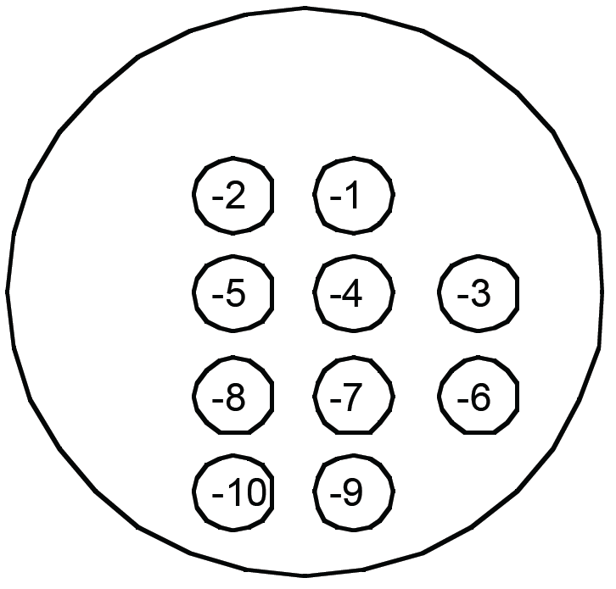

**Figure 2: Calculation of Titer from Spot Test** – The above spot plate contains spots of 10–1 through 10–10 dilutions. The 10–1 through 10–5 dilutions form cleared spots, and no plaques are evident on the 10–9 or the 10–10 spots. However, individual plaques are visible on the 10–6, 10–7, and 10–8 dilution spots. The 10–7 dilution spot above shows 28 plaques and the 10–8 dilution shows 3. Both spots yield approximately the same titer.

28 PFUs/10 μL x 1000 μL/1 mL x 107 = 2.8 x 1010 PFUs/mL

1. On the plate that was incubated overnight, count the plaques. Upon examination of the plates, choose a plate with roughly 20 – 200 plaques. Count each plaque, paying careful attention to the number of plaques in the adjacent plates. For example, if 50 plaques were observed on the 10–6 plate, 5 plaques should be expected on the 10–7 plate. Remember that it is statistically possible to diverge from the expected number, but be wary of error. If more than one plate with countable numbers of plaques are available, average the two values.

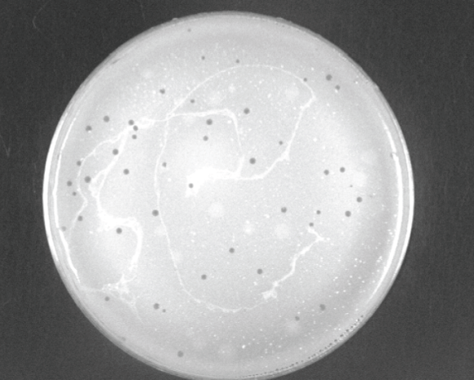

**Figure 3: Count the plaques in this photo –**

There are 50 on this 10–7 dilution plate

1. To calculate the titer, divide the number of plaques by the amount of sample plated. Multiply that number by the reciprocal of the dilution used to make that plate and convert μL to mL (multiply by 103) to obtain the titer in PFU/mL. Use the example calculation below, based on counting 50 plaques in the 10-7 spot:

Titer Calculation: 50 PFU/10 μL x 107 x 103 μL/mL = 5.0 x 1010 PFU per mL

**The number of PFU per mL calculated is the titer (concentration of PFU/mL).**