Phagehunting Program
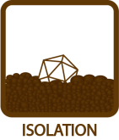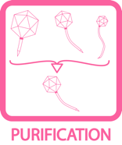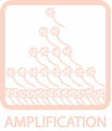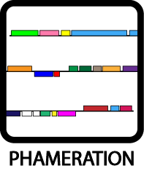

Phagehunting on Hosts of Actinomycetales

Purpose: The purpose of this project is to expand Phagehunting to hosts that are related to M. smegmatis mc² 155. The protocols are based on the standard Phagehunting Protocols found at phagesdb.org.

Background: After a quick canvass of current literature, we used papers and protocols as described in Petrovski et al (2011a and 2011b) and adapted them to soil sources. In these papers, the authors describe media system for the detection of phages of Tsukamurella, Gordonia, Rhodococcus, and Nocardia phages. In particular, the authors have described phages to Tsukmurella and Gordonia.

To expand our possible hosts we used four criteria to choose hosts.
- The hosts must be designated as BSL 1.
- The distribution would be simple. To that end, we used strains commercially available from ATCC.
- We chose a group of bacteria that could use the same media/detection system.
- We chose to use bacteria in the same suborder as Mycobacterium are found.

Class: | Actinobacteria
Order: | Actinomycetales
Suborder: | Corynebacterineae
Families: | Corynebacteriaceae
 | Nocardiceae
 | Gordoniaceae
 | Mycobacteriaceae

As of August 1, 2012, we have used the following hosts:

Host | BSL  (from ATCC) | ATCC # | # phages found
Arthrobacter sp. (formerly Nocardia globerula) | 1 | 21022 | 13
Nocardia corynebacteroides | 1 | 14898 | 0
Corynebacterium flavescens | 1 | 10340 | 4
Corynebacterium vitaeruminus | 1 | 10234 | 1
Corynebacterium glutamicum | 1 | 14020 | 2
Gordonia terrae | 1 | 25594 | 8
Rhodococcus globerulus | 1 | 15903 | 4
Mycobacterium smegamtis mc² 155 | 1 | 70084 | >21
As of August 1, 2012, we have acquired the following hosts to begin testing:

Host | BSL  (from ATCC) | ATCC # | Notes
Mycobacterium cookii | 1 | 49103 | Slower grower
Mycobacterium thermoresistibile | 1 | 19257
Mycobacterium aurum | 1 | 23366
Mycobacterium aichiense | 1 | 27281
Mycobacterium valentiae | 1 | 29356

Media and growth conditions:

A medium, which can be used readily for most species of these bacterial genera, is PYCa (Petrovski et. al. 2011).

For 1L PYCa add:
1.0g Yeast extract
15g Peptone
2.5mL 40% Dextrose
After autoclaving add 4.5ml 1M CaCl₂ .

For PYCa agar, add 15 g Bacto Agar to 1 L prior to autoclaving.
For PYCa top agar, add 7g Bacto agar to 1 L prior to autoclaving.

Depending on the bacterium they can be grown at 30 or 37°C, usually for 2 days although some genera, like Gordonia, can take up to 6 days.

Growing the bacteria: The PYCa liquid media is inoculated from one colony of the selected bacteria. We used baffled flasks that can hold 5x the volume of liquid culture desired. The flask is placed on a shaker and incubated at 30°C. Most of these bacteria grow up to stationary phase in 2-3 days.
Enrichment: Bacteria from these genera are readily found in soil as well as other environments such as sewage and in waterways, hence it is likely that phages are also present. Enrichment provides a higher probability of finding a phage. Enrich by adding media and bacteria to soil and allow to incubate for > 3 days.

Sample Preparation: Whether samples were enriched or not, an aliquot of the sample is filtered through a 0.2 um filter. The following procedure are based on the sample processing procedures as described in M. smegmatis Phagehunting Protocols (Found at phagesdb.org).
- Add 50 ul of filtered sample to 0.25 - 0.5ml of bacteria in a 7 ml sterile tube. Allow 10 minutes adsorption time.
- Add 4.5 ml of PYCa molten top agar to the above sample.
- Pour entire sample on a labeled PYCa agar plate.
- Allow to cool.
- Invert. Incubate at 30°C for 3 – 6 days.
- Observe for plaques. Once found, follow subsequent protocols found at phagesdb.org.

Note: Arthrobacter will also grow on LB media.
Notes:
- These abbreviated protocols are furthered explained in the Collecting & Screening Soil Samples Protocol found at phagesdb.org.
- To date, we have routinely enriched samples in a variety of ways. Using various amounts of media, bacteria, and soil, we have incubated the samples for > 3 days.
- All enriched samples are autoclaved prior to disposal.
- When growing the bacteria, clumping can be an issue, so Tween can be added in the initial culture from a single colony. Tween is omitted when growing cultures for plating for phage.
- Anti-bubble can be added to the agar preparations to avoid bubble formation (desirable).
- Most of these bacteria are slower growers than M. smegmatis mc² 155. Incubation days vary by strain and temperature.

Host | Incubation 30°C: Colonies (days) | Incubation 30°C: Liquid Culture (days) | Incubation 30°C: Lawn Formation (days)
Nocardia globerula | 1-2 | 1 | 1
Nocardia corynebacteroides | 4-5 | 2 | 2
Corynebacterium flavescens | 2-3 | 1-2 | 1-2
Corynebacterium vitaeruminus | 2-3 | 1-2 | 1-2
Corynebacterium glutamicum | 1-2 | 1-2 | 1-2
Gordonia terrae | 4-5 | 2-3 | 2-3
Rhodococcus globerulus | 2-3 | 1-2 | 1-2
M. smegmatis mc² 155  (grown at 37C) | 3-4 | 1-3 | 1-2

- With incubation at 30°C, the growth time is longer than M. smegmatis.
- All of these bacteria are pigmented, ranging in color from yellow to orange.

Hosts:
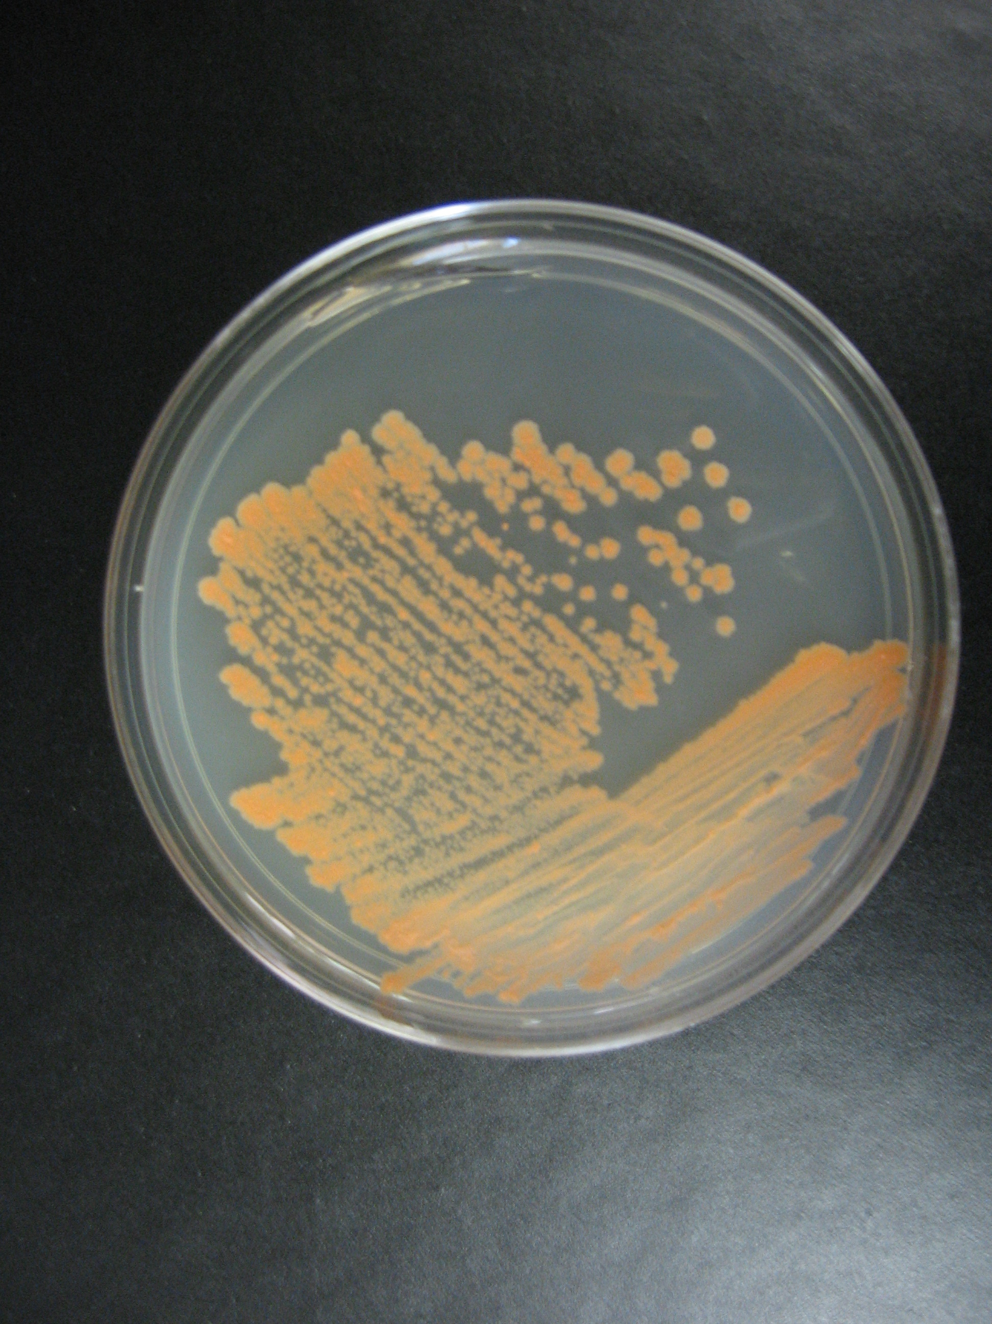 | 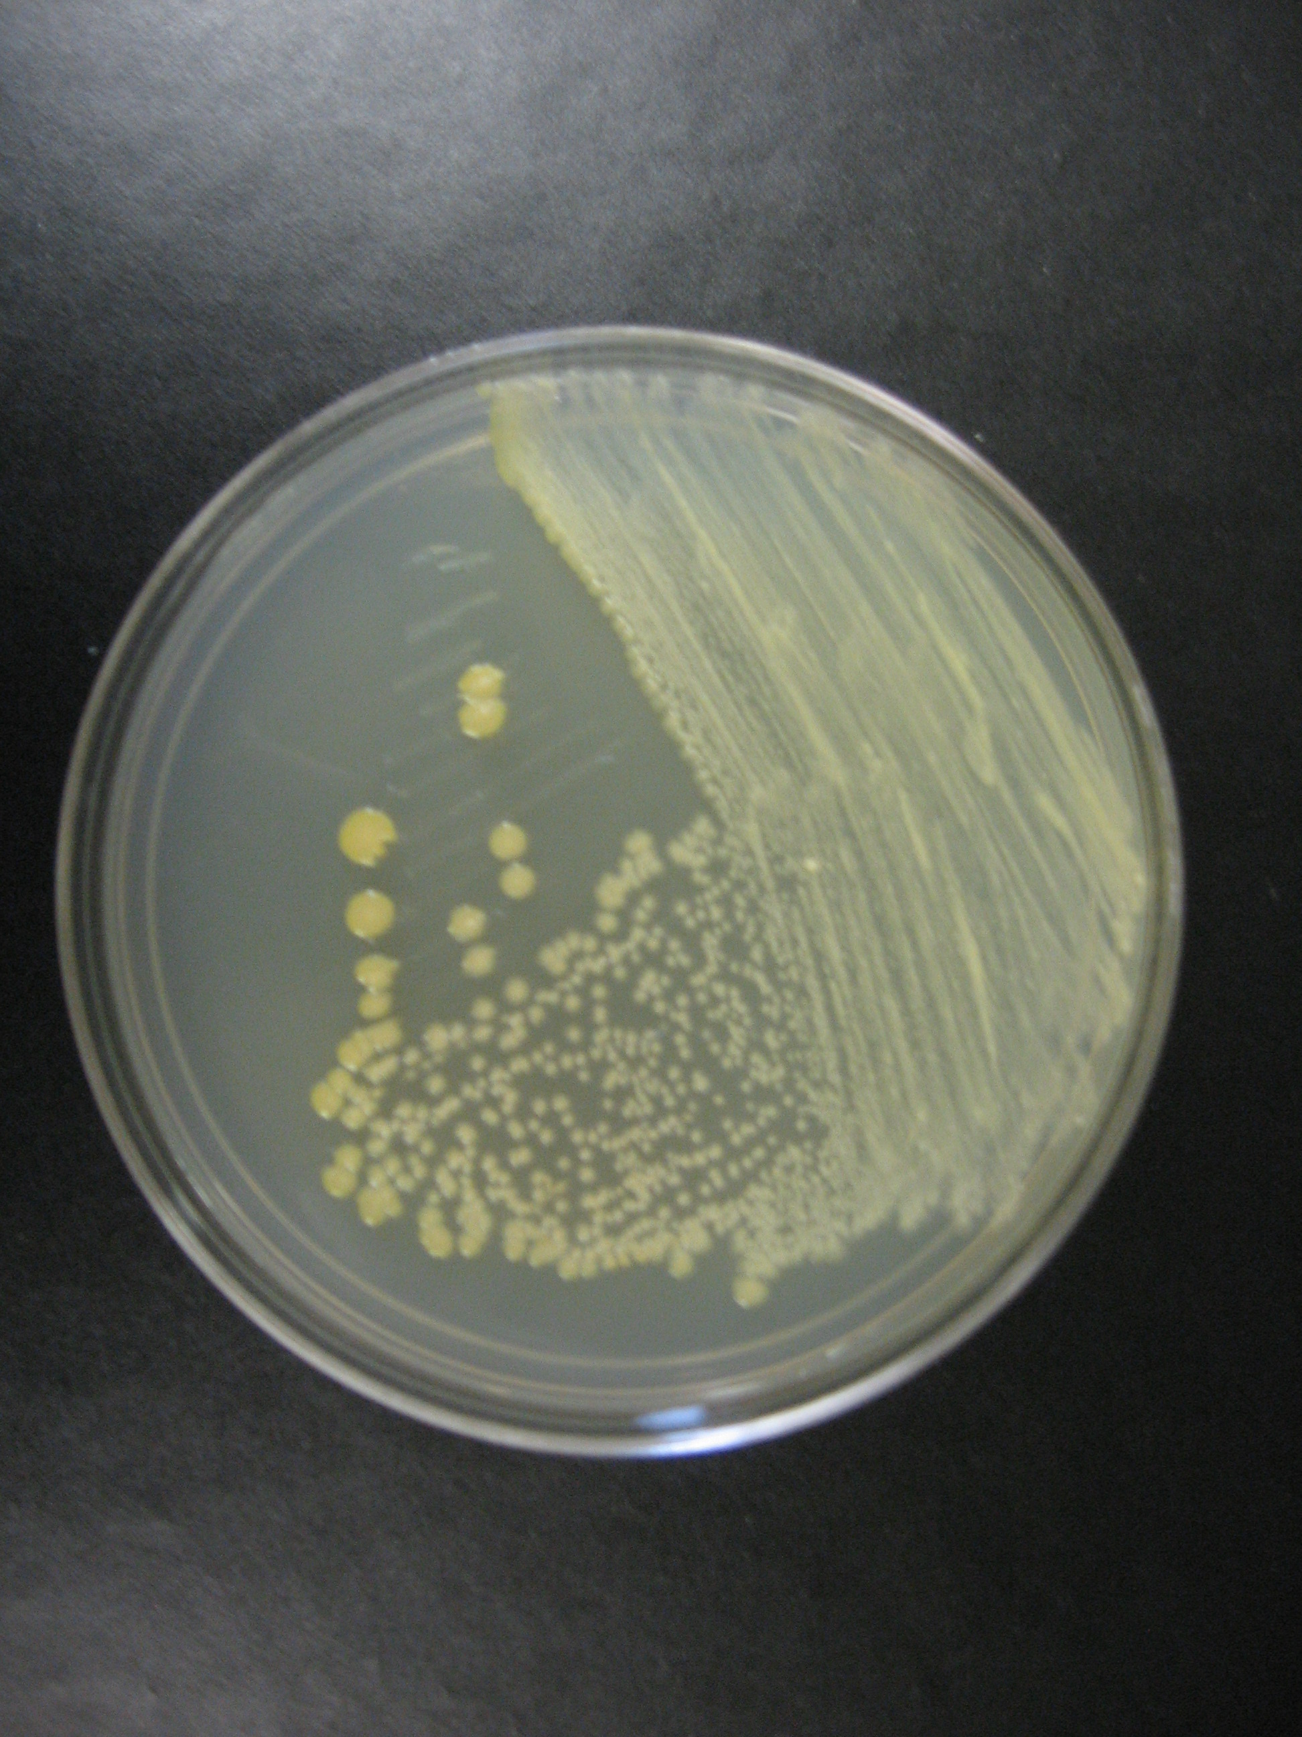 | 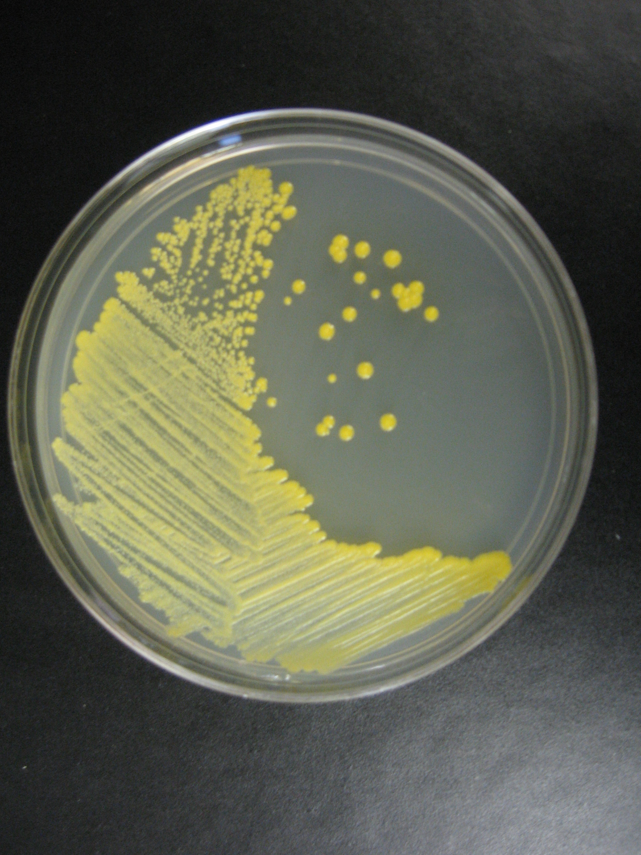
G. terrae | C. vitaeruminus | C. glutamicum
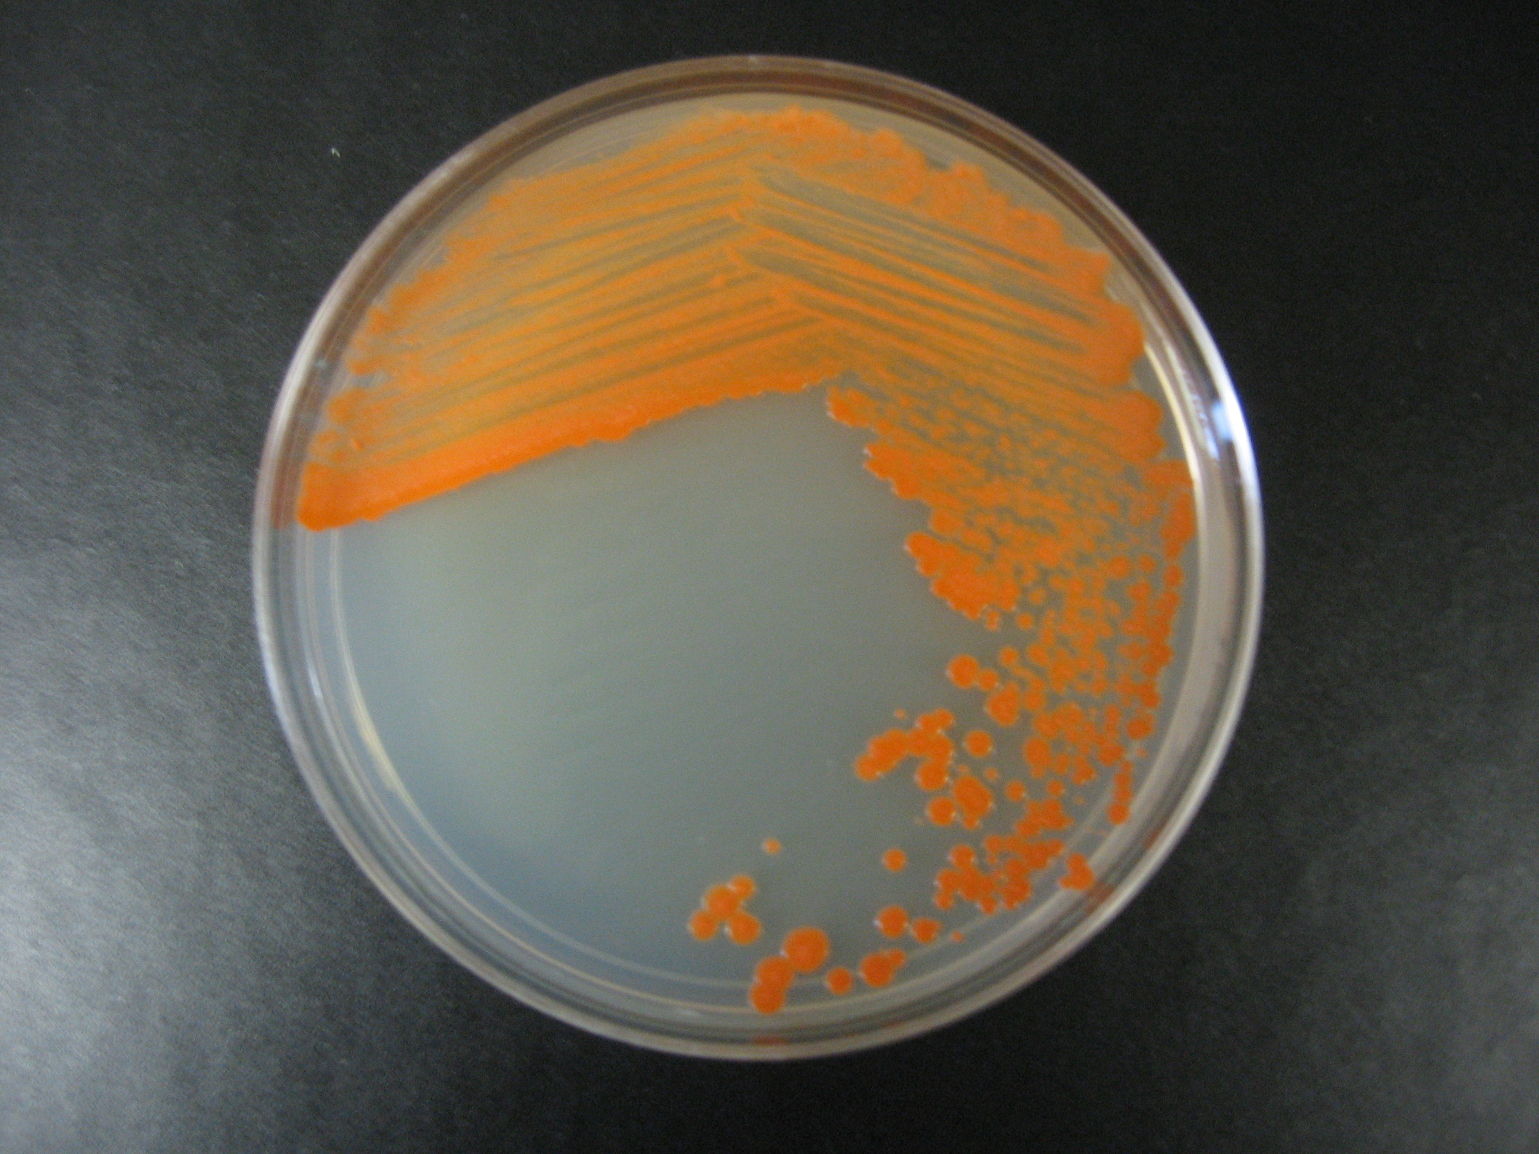 | 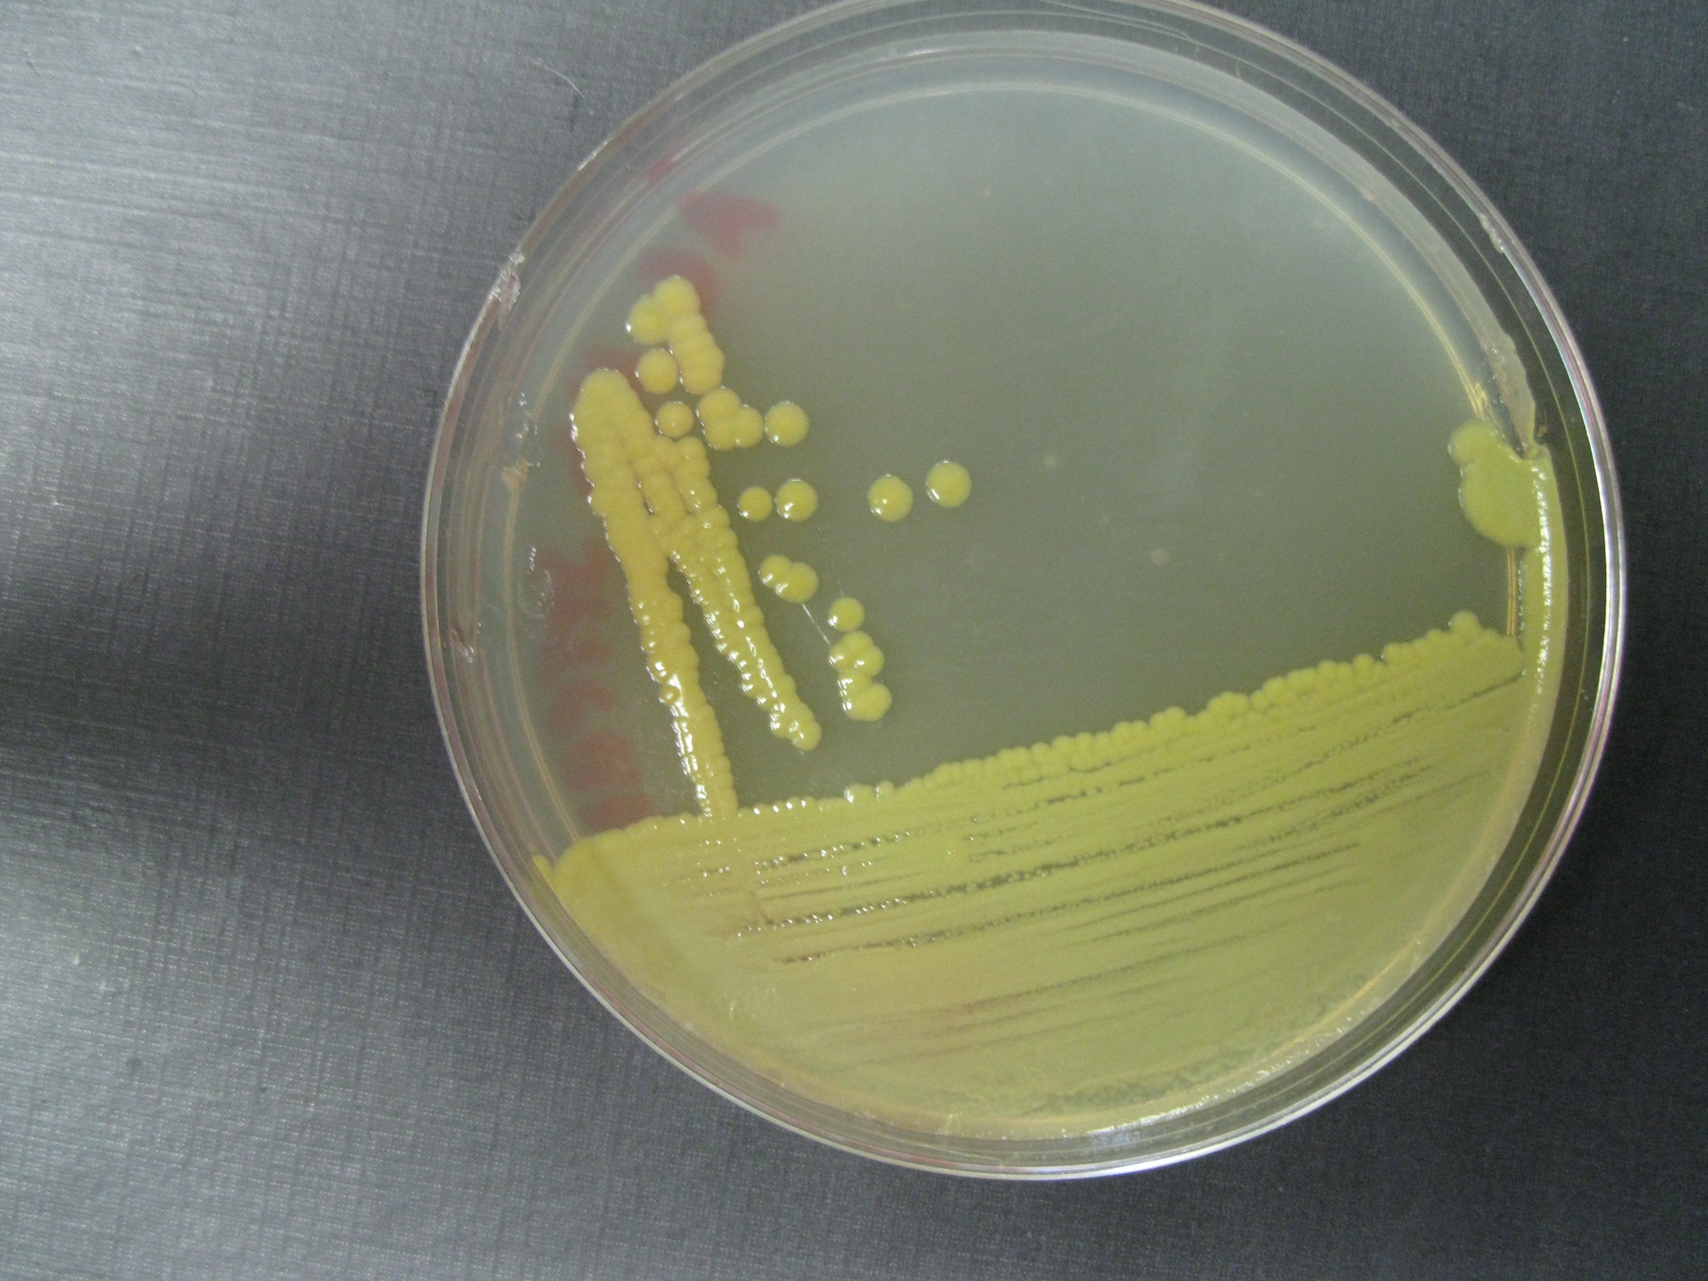 | 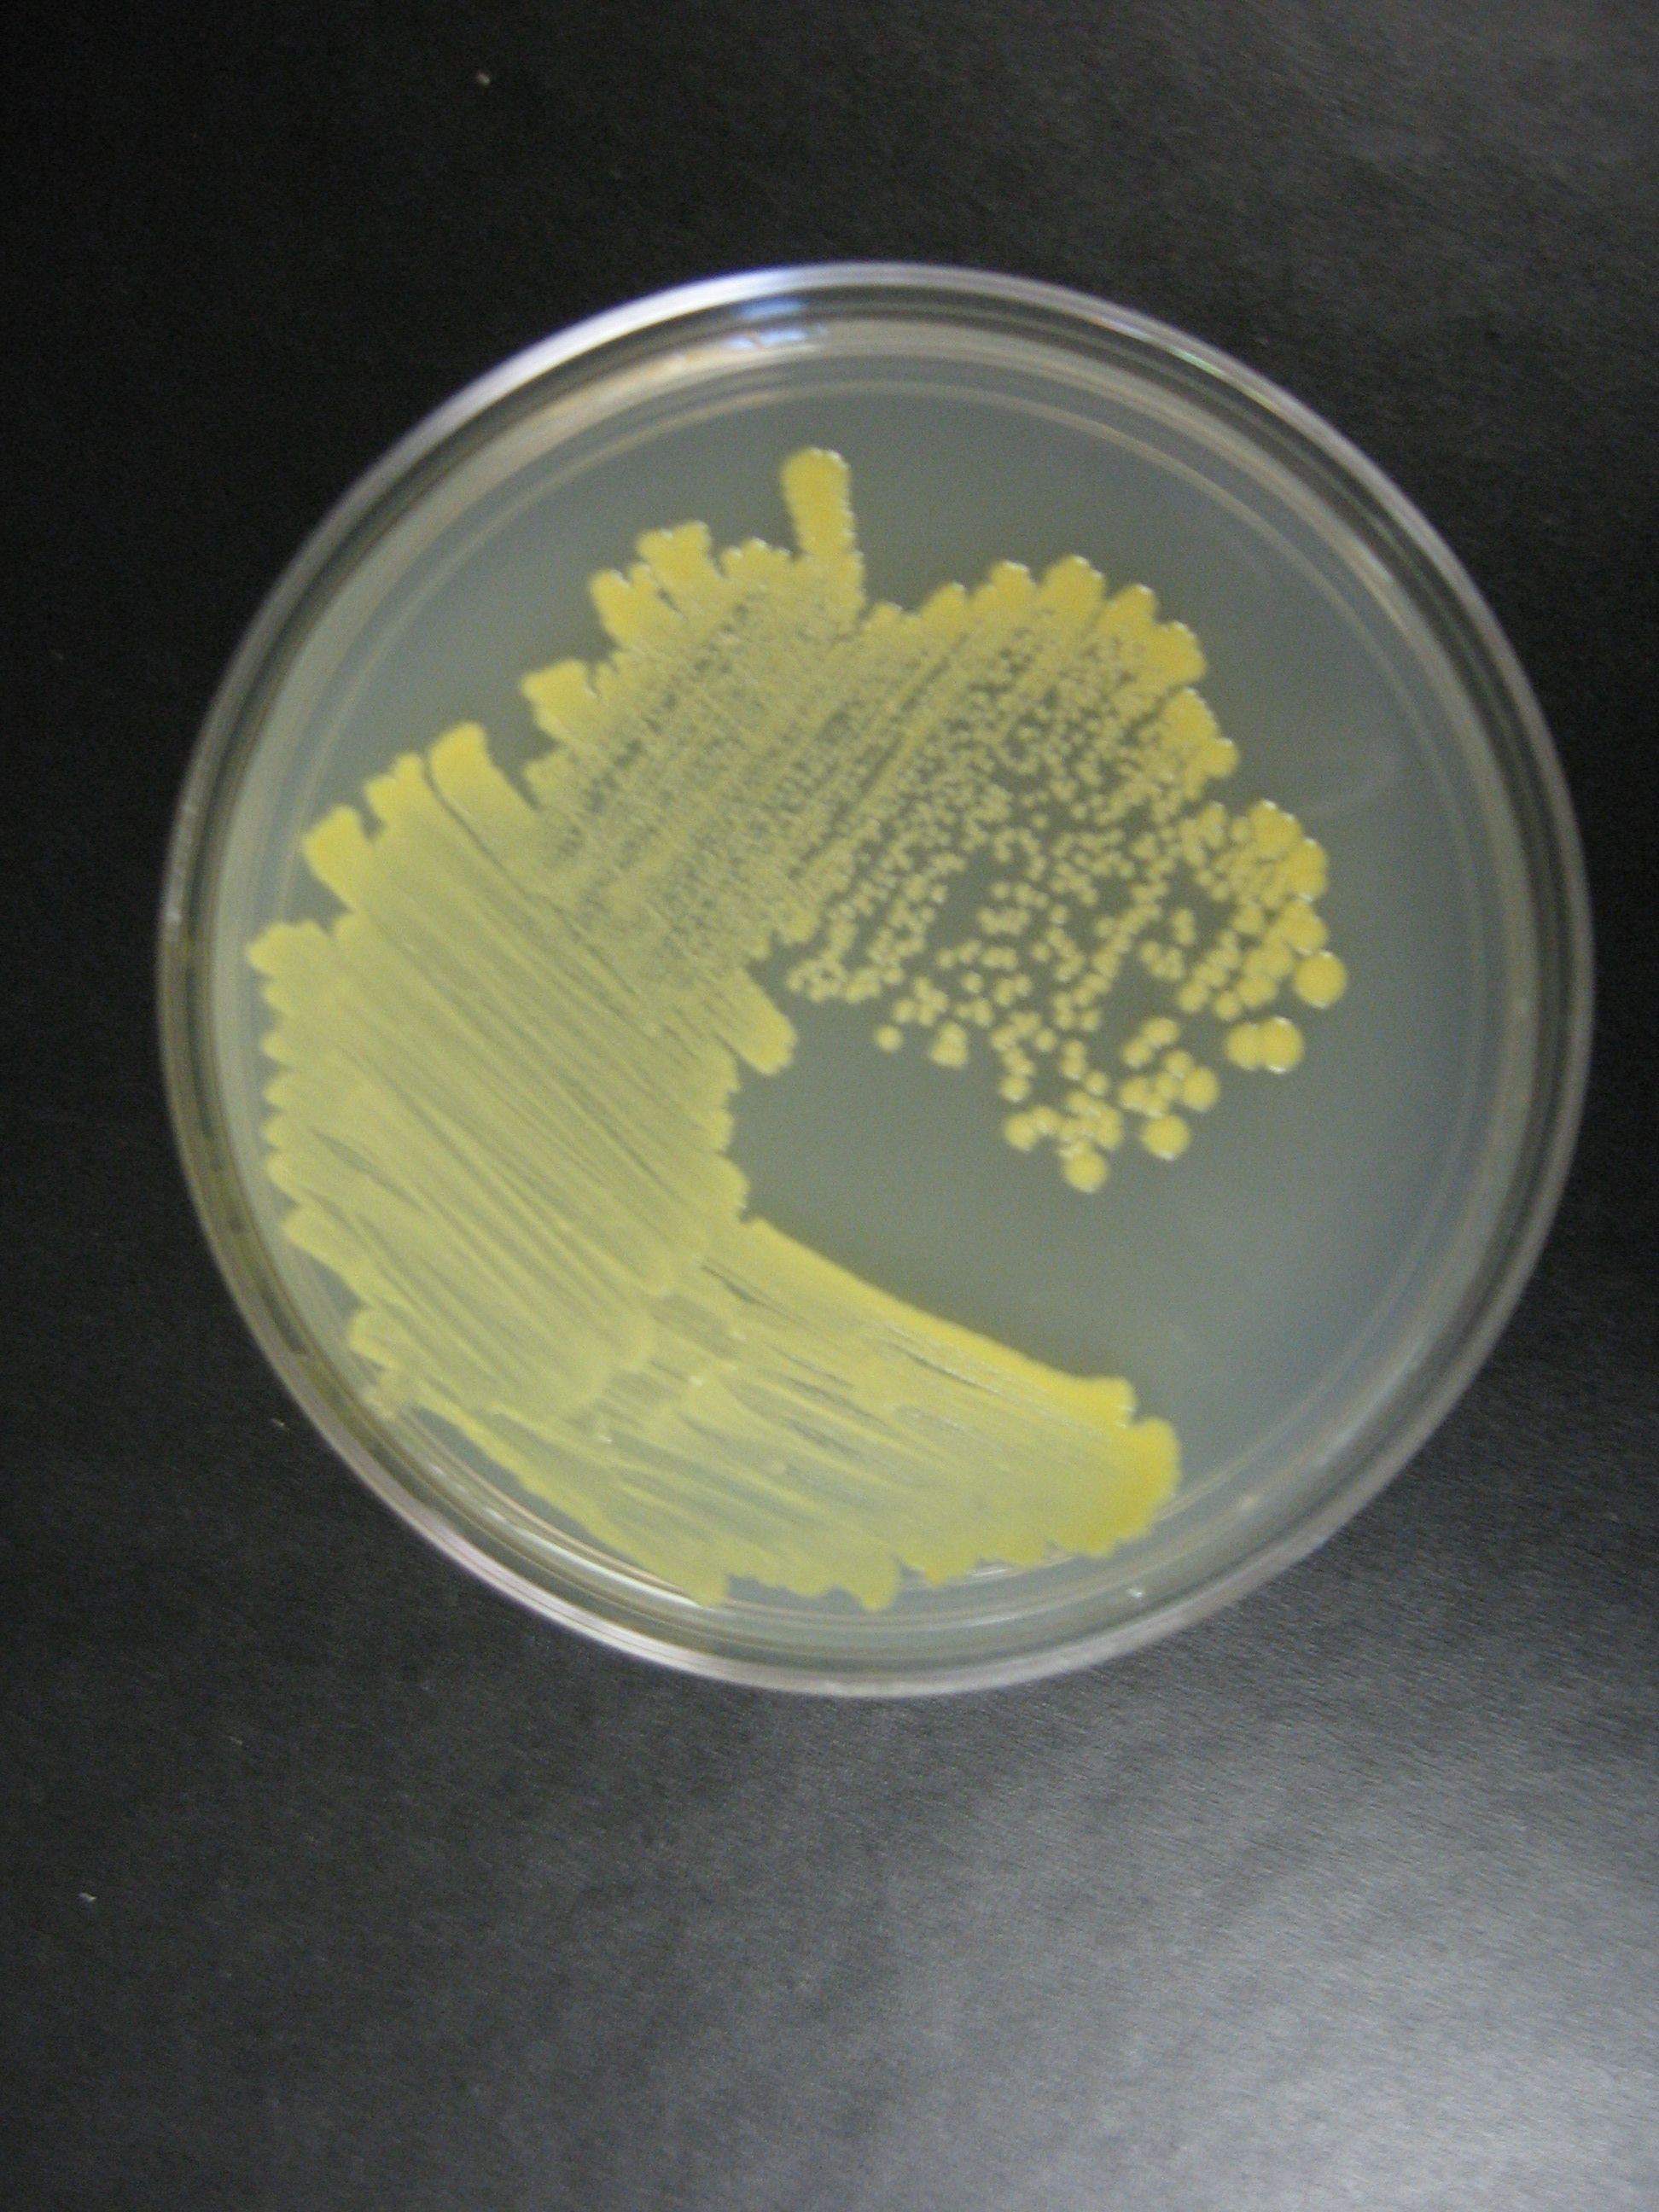
N. corynebacteroides | N. globerula | C. flavescens

Plaque morphologies:
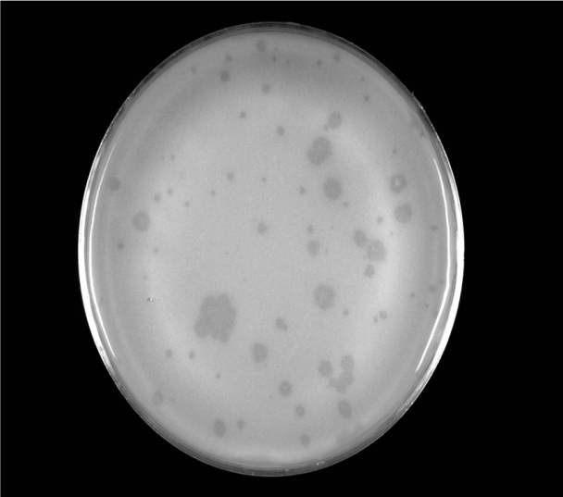 |  | 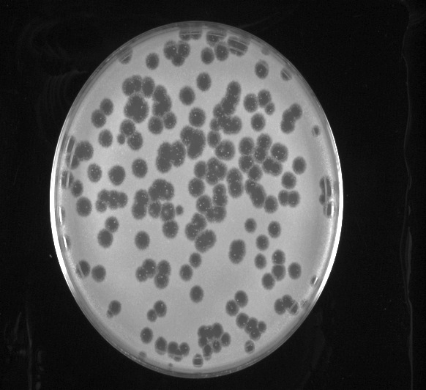
CF Phage: DianaPS | CG Phage: Zombie | NG Phage: Jawnski
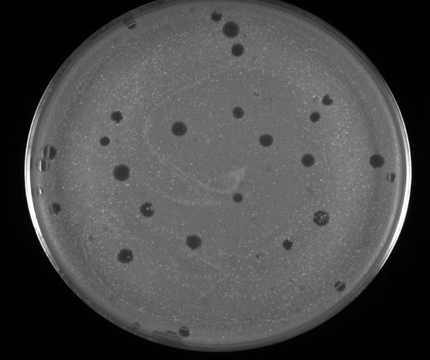 | 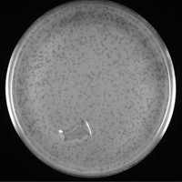 | 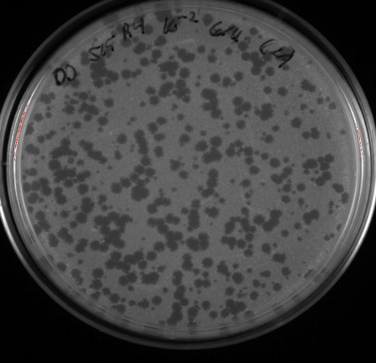
RG Phage: Erik | NG Phage: Gordon | GT Phage: Brujo

Virion Particle Morphologies:
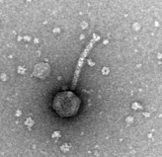 |  | 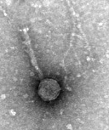 | 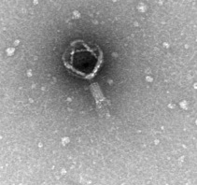
NG Phage: Ollie | NG Phage: Bennie | NG Phage: Korra | NG Phage: Gordon

References and Resources:

Phagesdb.org

Resource Guide of HHMI SEA-PHAGES

Petrovski, S., Seviour, R. J., & Tillet, D. (2011). Genome Sequence and Characterization of the Tsukamurella Bacteriophage TPA2. Applied and Environmental Microbiology, 77(4), 1389-1398.

Petrovski, S., Seviour, R. J., & Tillet, D. (2011). Characterization of the Genome of the Polyvalent Lytic Bacteriophage GTE2, which has Potential for Biocontrol of Gordonia-, Rhodococcus-, and Nocardia- Stabilized Foams in Activated Sludge Plants. Applied and Environmental Microbiology, 77(12), 3923-3929.

